**ASSIGNMENT 4**

**INTRODUCTION TO PROCESSES**

1. C program to demonstrate system call are made 2^n time in fork

Code:

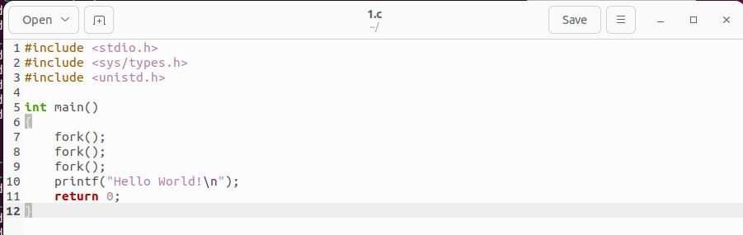

Output:

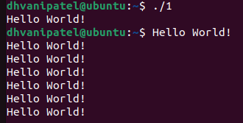

1. C program to demonstrate two process run at same time

Code:

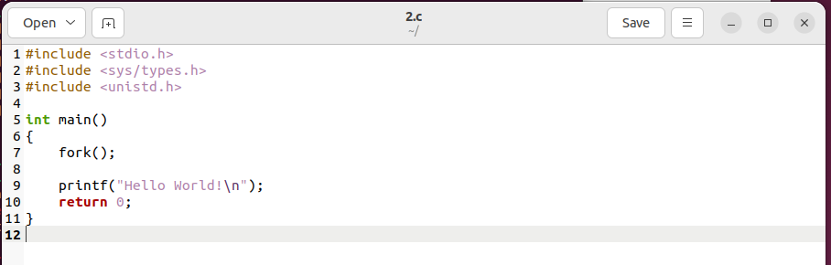

Output:

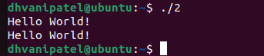

1. C program to demonstrate Parent process and child process

Code:

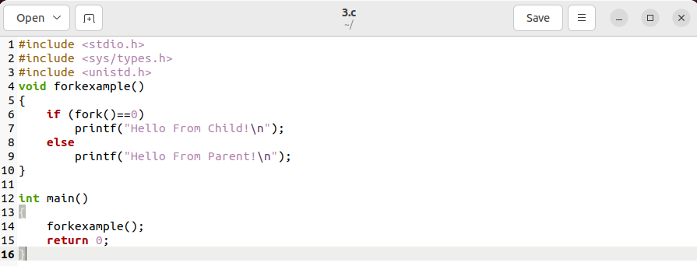

Output:

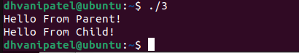

1. C program to demonstrate Orphan process

Code:

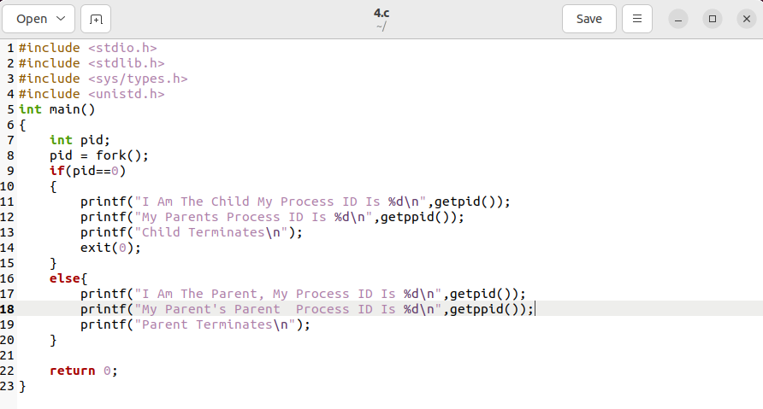

Output:

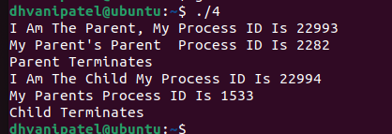

1. C program to demonstrate zombie process.

Code:

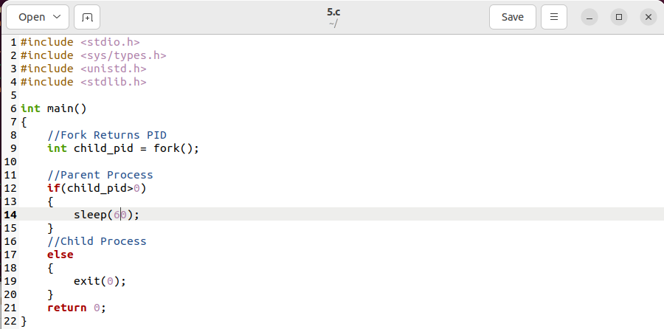

Output:



1. C program to demonstrate Orphan process.

Code:

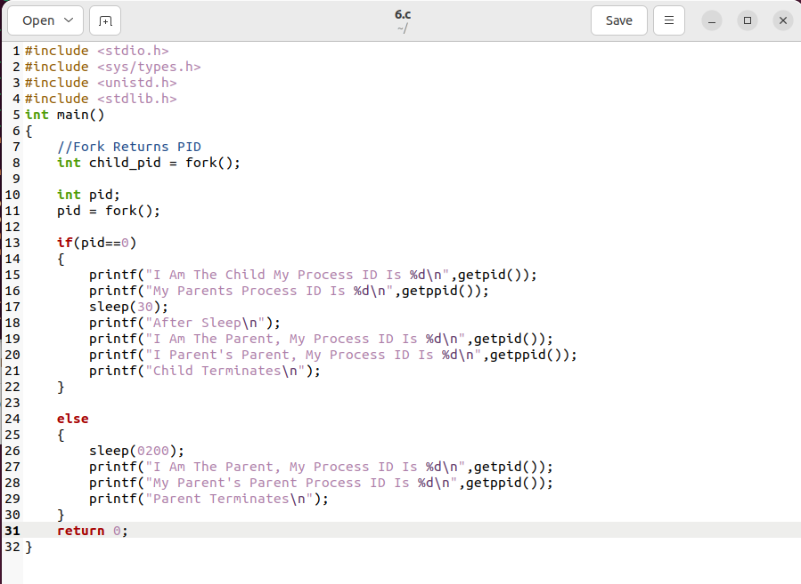

Output:

